**Artificial Intelligence and Data Science Department.  
Computer Networks / Even-Sem 2021-22 / Experiment 7.  
_________________________________________________________________**

**YASH SARANG.  
47 / D11AD.  
EXPERIMENT - 7.  
_________________________________________________________________**

**Aim:**

Design and Simulate VLANs on the switch/router using Cisco packet tracer/ GNS3.

**_________________________________________________________________**

**Theory:**

VLANs (Virtual LANs) are logical grouping of devices in the same broadcast domain. VLANs are usually configured on switches by placing some interfaces into one broadcast domain and some interfaces into another. Each VLAN acts as a subgroup of the switch ports in an Ethernet LAN.

VLANs can spread across multiple switches, with each VLAN being treated as its own subnet or broadcast domain. This means that frames broadcast onto the network will be switched only between the ports within the same VLAN.

A VLAN acts like a physical LAN, but it allows hosts to be grouped together in the same broadcast domain even if they are not connected to the same switch. Here are the main reasons why VLANs are used:

* VLANs increase the number of broadcast domains while decreasing their size.
* VLANs reduce security risks by reducing the number of hosts that receive copies of frames that the switches flood.
* you can keep hosts that hold sensitive data on a separate VLAN to improve security.
* you can create more flexible network designs that group users by department instead of by physical location.
* network changes are easily achieved by configuring a port into the appropriate VLAN.

**_________________________________________________________________**

**Output:**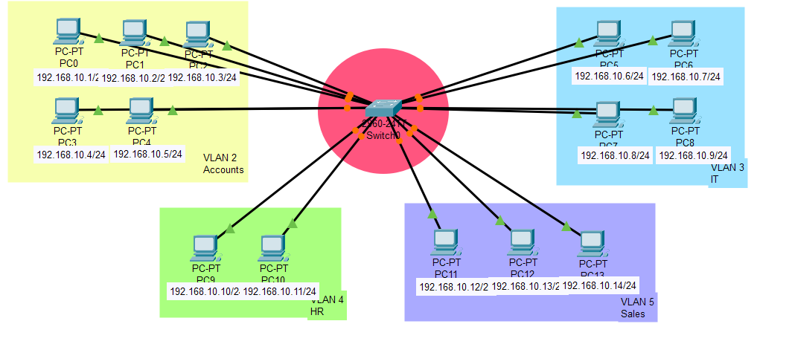

Pinging from PC10 to PC11

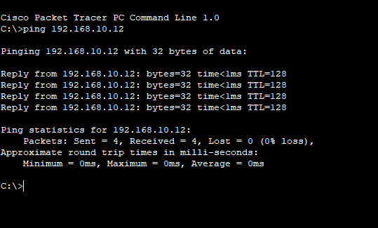

**_________________________________________________________________**

**Conclusion:**

We have studied, learned, and successfully implemented to make the VLANs have been simulated using a Cisco packet tracer.

**_________________________________________________________________**

**\*\*\*\*\***